# DFD for Food Ordering System

A food ordering system is essentially a software that enables restaurant managers to oversee and take orders that are placed in-person or over the Internet. Let's use a data flow diagram, or DFD, to better understand how the food ordering system operates. Below is the DFD for the food ordering system**.**

Various DFD levels, including Level 0 DFD, Level 1 DFD, Level 2 DFD, and Level 3 DFD, are displayed here for the Food Ordering System.

## **Level 0 DFD –**

At this level, the Input and Output of the system are shown.

* + Food Ordering System has the following input:
    - Food order is input as the customer’s order for food.
  + Food Ordering System has the following output:
    - Receipt of the order.
    - For further processing the order, the food order is passed to the kitchen.
    - The restaurant manager gets the report of Bill and Management.

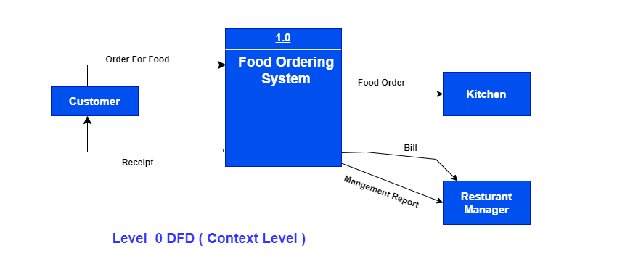

Figure 1 Level 0 DFD

## **Level 1 DFD –**

Process 1.0 is in charge of processing the order. The associated housekeeping tasks for food are symbolized by processes 2.0, 3.0, and 4.0. The inventory data (which describes the records of datasets such as their name, their content, their source, many useful information, etc.) should be maintained at the same time as the detailed information about daily sold items is made available to create and report management.

Therefore, the DFD level shown below uses the following two data stores:

* Database of goods sold
* Database for inventory

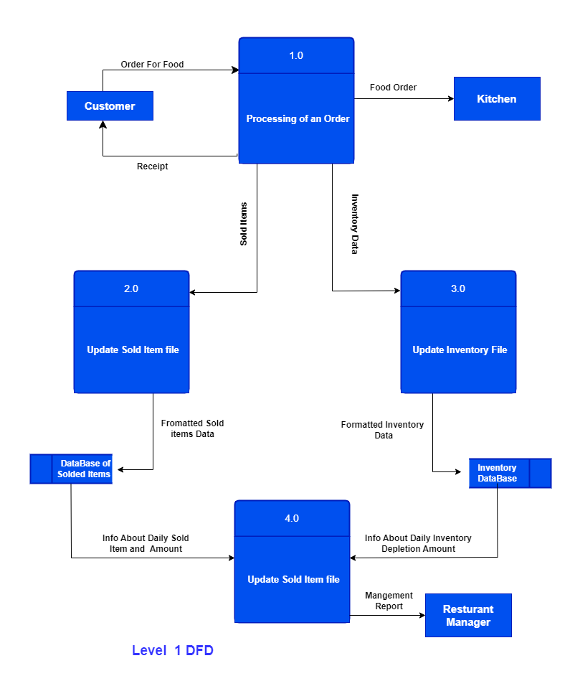

Figure 2 Level 1 DFD

## **Level 2 DFD –**

Below is detailed information regarding "Processing of an Order":

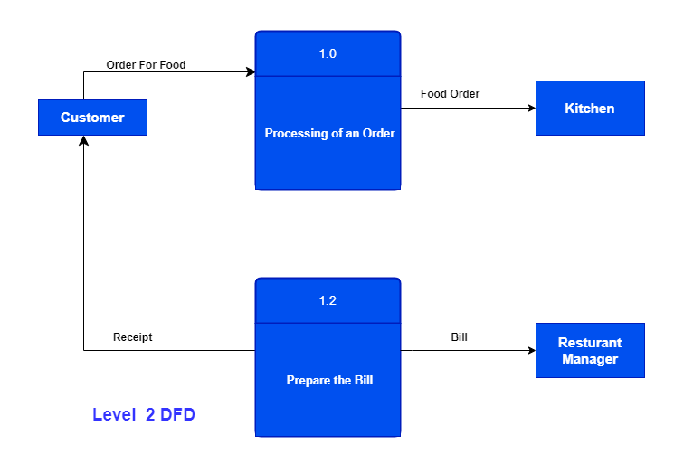

Figure 3 Level 2 DFD

## **Level 3 DFD –**

At this DFD level, more specific details regarding the "Generate Management Report" activity are provided. To generate a management report, it is necessary to have access to inventory and sold item data. The management report that is generated from the aforementioned computations should then be given to the restaurant manager once the data for both solid goods and inventory have been combined.

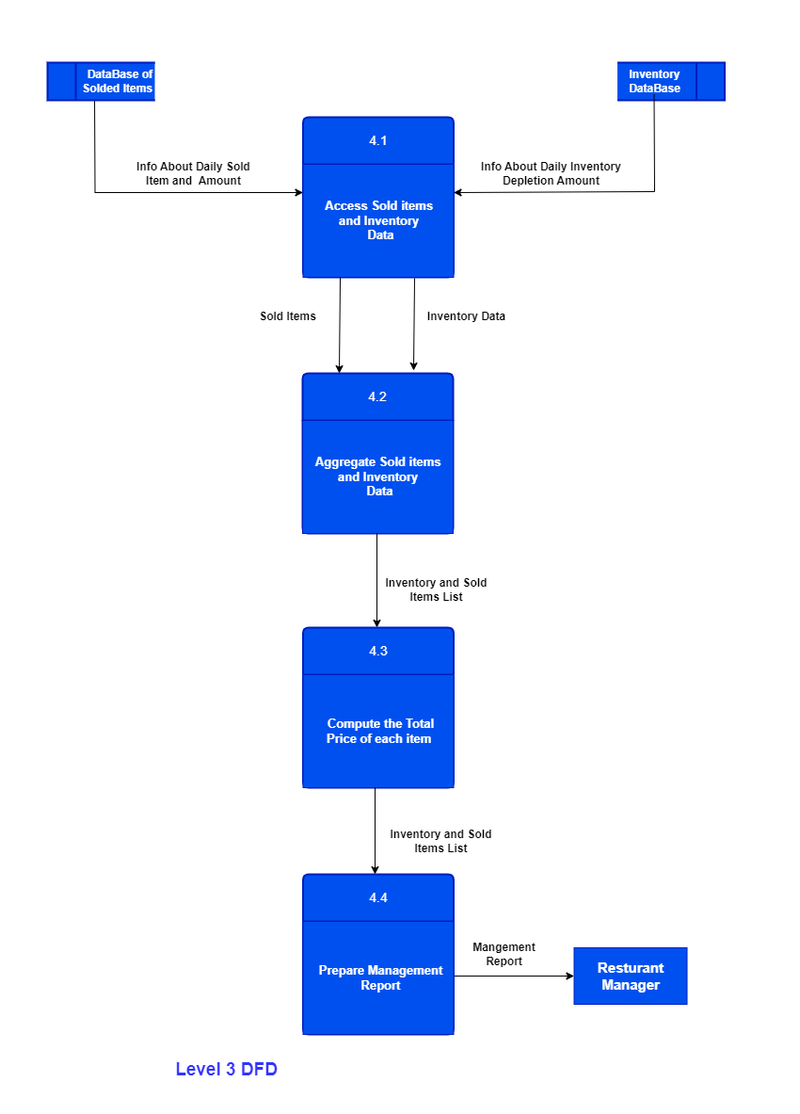

Figure 4 Level 3 DFD

# Use Case Diagram of Food Ordering System

## First:

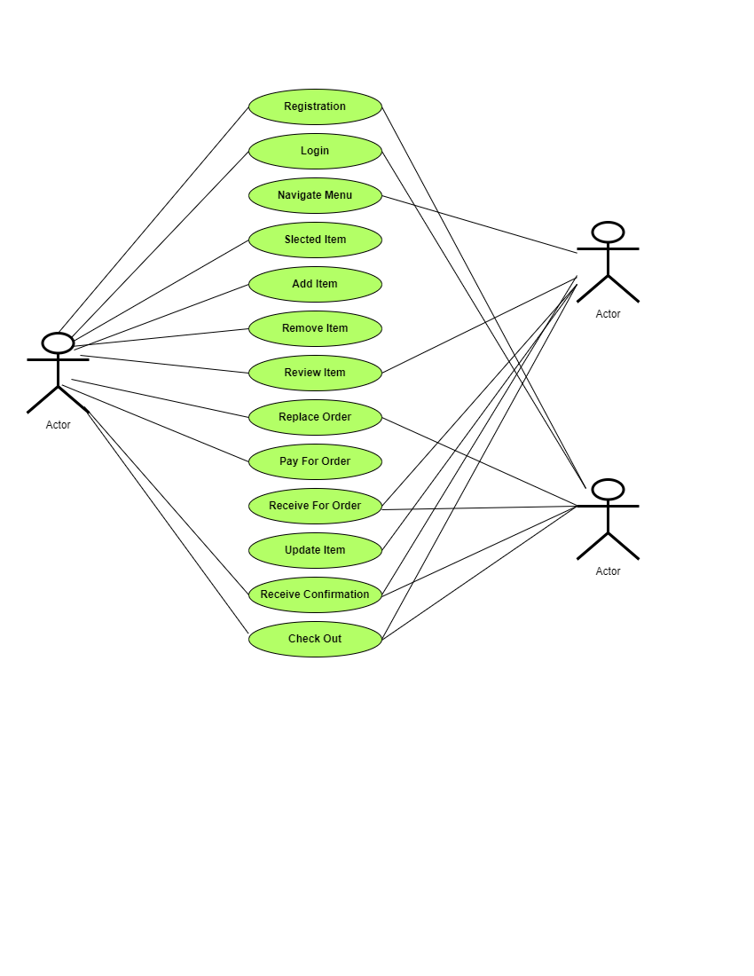

**Figure 5: Use Case Diagram**

## Second:

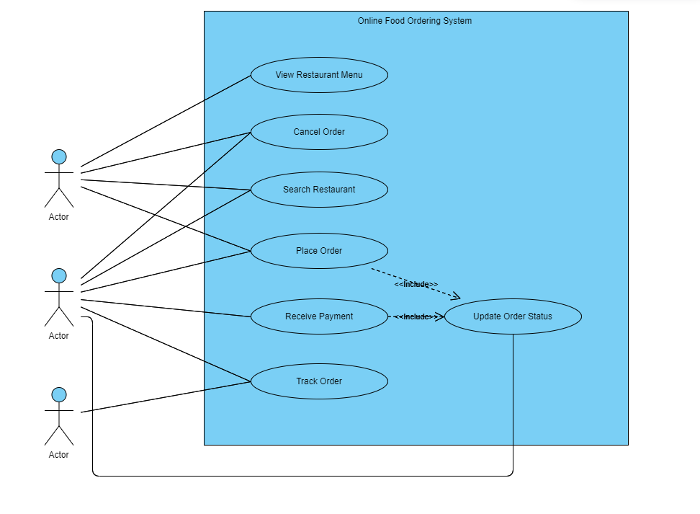

Figure : Use Case Diagram